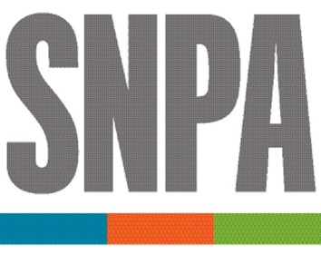
FOUNDATION

SNPA FOUNDATION GRANT SUPPORTS THE RELEVANCE PROJECT

The SNPA Foundation has awarded a $25,000 grant to help support The Relevance Project, an initiative of Newspaper Association Managers. The grant is renewable in 2022, subject to a performance review by the SNPA Foundation board.

The Foundation grant continues a long history of collaboration by SNPA with state newspaper trade associations and community newspapers. In making the grant, the Foundation board expressed hope that this venture will seed further cooperation and coordination among newspaper industry associations.

"We think it's important for this initiative to succeed to help associations strengthen their member newspapers," said P.J. Browning, chair of the SNPA Foundation and newspaper division president of Evening Post Publishing in Charleston, SC. "We value being a part of that refreshing collaboration."

The grant is a first for both organizations. It is the initial award made by the SNPA Foundation since it was re-established as an independent, non-profit in the merger that created America's Newspapers. And, it is the first outside funding received by The Relevance Project after being developed in 2018 and formally launched in 2020 with www.relevanceproject.net

"Grants like this are difference-makers and we appreciate SNPA Foundation's endorsement of The Relevance Project," said Steve Nixon, NAM president and the executive director of the Saskatchewan Weekly Newspapers Association in Canada. "Press associations and their advocacy on behalf of community newspapers are vitally important to our industry, markets and democracy."

Disclosure note:
Thomas A. Silvestri is executive director of The Relevance Project and a member of the SNPA Foundation Board. He didn't participate in the review of the grant application nor the approval.

ABOUT THE NEWSPAPER ASSOCIATION MANAGERS:
NAM is a coalition of state, provincial, and national trade groups representing newspaper media in the United States and Canada. NAM fosters communication and the sharing of ideas and information among its members for the benefit of the newspaper associations managed by NAM members.

ABOUT THE SNPA FOUNDATION:
The SNPA Foundation works to preserve the prosperity and the future of newspapers. Programs endorsed by the SNPA Foundation spotlight the critical need for ethical journalism, explore sustainable business models that help newspapers operate in an evolving media environment, and promote the value that newspapers bring to the communities that they serve.

For further information, please contact Edward VanHorn, SNPA Foundation secretary,
at edward@snpafoundation.org or 678.462.8448.

